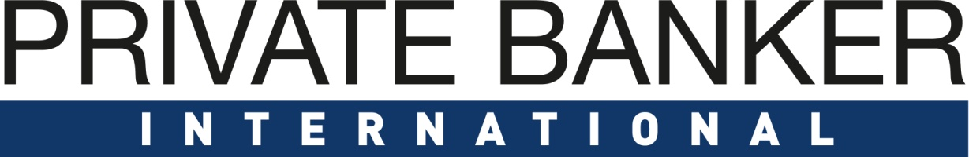

Private Banking: London Awards 2022
15th June 2022 – London, UK

Entry Form
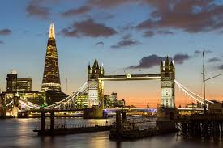

PART A – must be received by 16.05.2022
Company Details
Company Name
Company Address (including Postcode)
Contact Person
Contact Details
Submission Details
Item |  | Details
Tick Submission Award Categories

 |  | Outstanding Private Bank – UK - Domestic Clients
 |  | Outstanding Private Bank – UK - International Clients
 |  | Outstanding Private Bank – UK Crown dependencies
 |  | Outstanding Private Bank – Nordic region
 |  | Outstanding Private Bank – Western European region
 |  | Outstanding Private Bank – Eastern European region
 |  | Outstanding Private Banking Client Engagement
 |  | Outstanding Wealth Management Technology Provider – middle office (vendor)
 |  | Outstanding Wealth Management Technology Provider – back office (vendor)
 |  | Outstanding Digital Solutions Provider (vendor)
 |  | Outstanding Private Bank for Next Generation Proposition
 |  | Outstanding Private Bank for UHNW Clients
 |  | Outstanding Private Bank for Philanthropy Proposition
 |  | Outstanding Private Bank for Sustainable and Ethical Investment
 |  | Outstanding Private Bank for Diversity and Inclusion
 |  | Employee Engagement

PART B – must be received by 16.05.2022
Award Snapshot
(Please describe in between 500 – 1000 words or less why your programme or product should be nominated in this category. Please refer to the bullet points below the category when outlining your rationale.) Graphs and pictures can be copied into this document.

Website URL
Any other details you wish to share

Please send this form to leonidas.trapotsis@arena-international.com by 16.05.2022

There are several general and social media sponsorship options available if you would like to sponsor an award, a category or social media interactions. Please get in touch with Ray Giddings – ray.giddings@arena-international.com for further information.

